**Client-Side App Rubric** <https://github.com/denisecase/pbl-lifeline-links>

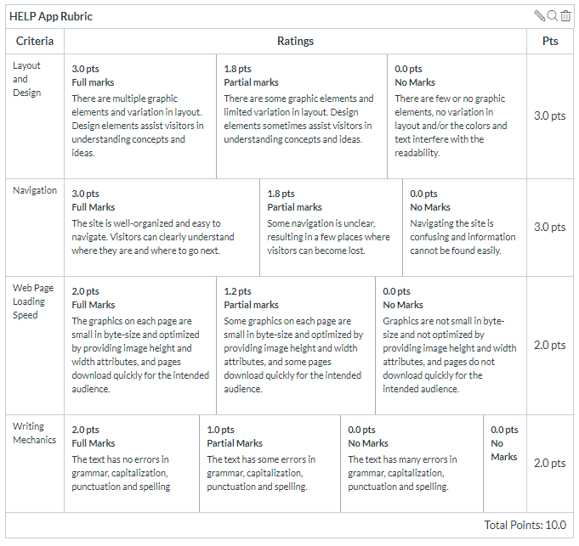

**Team reviewed: Group 02-02**

**Link to the web site:** <https://aawajjoshi.github.io/pbl-lifeline/>

**Layout and Design**

Score: 1.8

Comments: On all the pages there is excess white space between content. Image and text should be inline on the landing page. There is two of the same button on landing page and they are not linkable. The hovers that don’t link are confusing because we feel like hovers are supposed to link in most cases and is distracting from the purpose of the site. The lower left hand picture on the landing page seems awkward and out of place. Pricing and contact pages are blank

**Navigation**

Score: 3

Comments: The help at the top of the page doesn’t link back to the home page.

**Loading Speed:**

Score: 2

Comments: Did not have any loading problems

**Writing Mechanics:**

Score: 2

Comments: Some information on the about page is very wordy and maybe could use bullet points or make it shorter.

**General remarks: Over all if the changes to the site are made so it looks less awkward we like the site and it looks really clean and user friendly.**

**Review performed by:**

**Date and time performed: 12/3/2019 1:44pm**